
HEADLINES FROM HILLSBOROUGH COUNTY

October 22, 2019
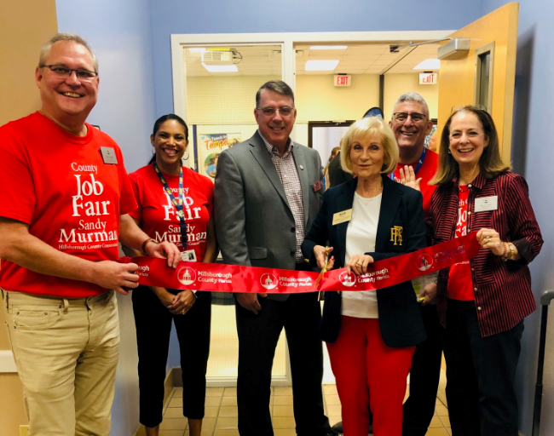

Commissioner Sandy Murman cuts the ribbon for the start of the County Job Fair at the Hillsborough Community College’s Student Services Building last Friday held on HCC’s Dale Mabry campus. The job fair was hosted by Hillsborough County Commissioner Sandy Murman, in association with CareerSource Tampa Bay and HCC. Nearly 60 employers and vendors and over 300 people seeking employment participated in the free event, including Busch Gardens, Hillsborough County Schools, Moffitt Cancer Center, Zoo Tampa at Lowery Park, Bank of America and Seminole Hard Rock Tampa. Nearly all of the employers surveyed by CareerSource rated the event as excellent. “It was very successful and we’re very happy we’re getting people back to work,” Murman said.

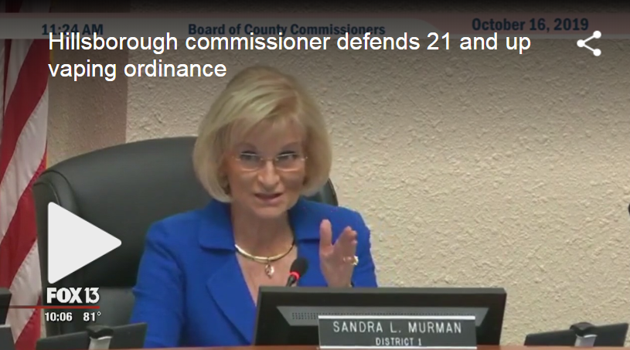
Hillsborough County commissioner aims to raise age to buy vaping products
Young people may soon have a harder time buying vape products in Hillsborough County, if Commissioner Sandy Murman has her way. She proposed an ordinance that would increase the age limit to buy vaping supplies from 18 to 21. "This is all to keep our children safe, it's the bottom line," said Murman, who spearheaded the proposal. The Hillsborough County Commission will take up the issue again November 6th.


Florida attorney general opens investigation into vaping companies’ marketing practices
State Attorney General Ashley Moody said the investigation, which follows a fact-gathering mission over the summer, will examine if how vaping products are promoted violates any laws, particularly those that prohibit selling the products to minors. Just as Moody took the microphone, the Hillsborough County Commission held the first of two public hearings on the board’s own effort to curb youth vaping

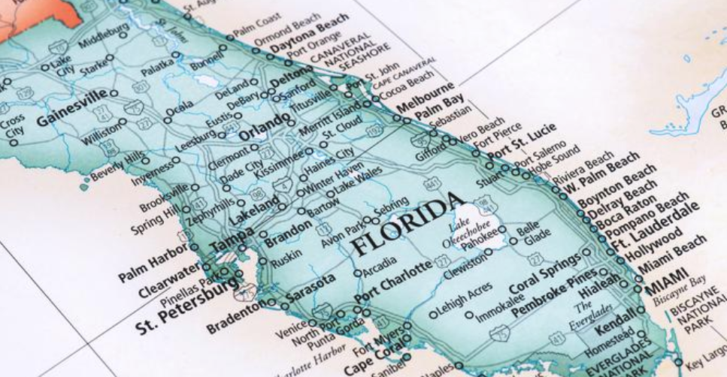
Tampa among top U.S. cities in 2019 for growth
New York-based WalletHub ranked over 515 cities on economic growth over several years, considering over 17 separate areas to score each city as part of an index out of 100. Those metrics included population growth, job growth, building-permit activity, growth in businesses and other economic factors. The study broke the cities into three categories: large, more than 300,000, midsize, 100,000 to 300,000 and small, fewer than 100,000.
Faces Behind the Places
Dale Mabry Highway

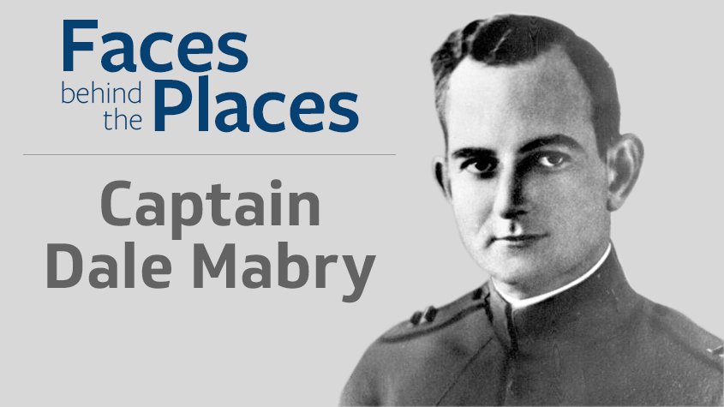

Hillsborough County is full of inspiring, iconic, and interesting places, and there are remarkable people behind them. In this occasional series we explore namesakes of some of the county's well-known buildings, parks, and roads.

Who was Dale Mabry?
Mabry, 1891-1922, was a pioneer aviator. A captain with command of the U.S. Army's 10th Balloon Company in World War I, he returned home to Florida after the hostilities but remained in the military service. He was at the wheel of Airship Roma in a test flight over Norfolk, Va., when the dirigible's steering failed and the aircraft crashed on Feb. 21, 1922. Mabry and 33 other men aboard the aircraft died. It was the worst tragedy in the young history of American aeronautics.

Why name a road for him?
At the dawn of aviation, pilots were revered. When the first segment of a road connecting Drew Field (now the site of Tampa International Airport) with MacDill Field (now MacDill Air Force Base) was completed in the early 1940s, it was named in honor of Capt. Dale Mabry. Mabry Elementary School, 4201 W. Estrella St., in South Tampa, also honors the aviator.

About Dale Mabry Highway
The north-south road is the longest road in Tampa, stretching from the Air Force base north into Pasco County. Dale Mabry Highway is a key artery for daily commuters, linking South Tampa with Carrollwood, Lutz, Land O' Lakes, and other communities. The road borders Raymond James Stadium, George M. Steinbrenner Field, and the original Hillsborough Community College campus.

UPCOMING EVENTS IN THE COUNTY

Thursday, October 24th 9:00 AM – Board of County Commissioners Land Use Meeting, County Center

Thursday, October 24th 6:00 PM – BOCC Comp Plan Public Hearing, County Center

Click on this to see a list of BOCC Agendas
WHAT’S ON THE BOCC AGENDA?
STAY CONNECTED

Call my Office: 813-272-5470 | www.sandymurman.com

