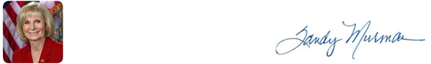
HEADLINES FROM HILLSBOROUGH COUNTY

October 16, 2019
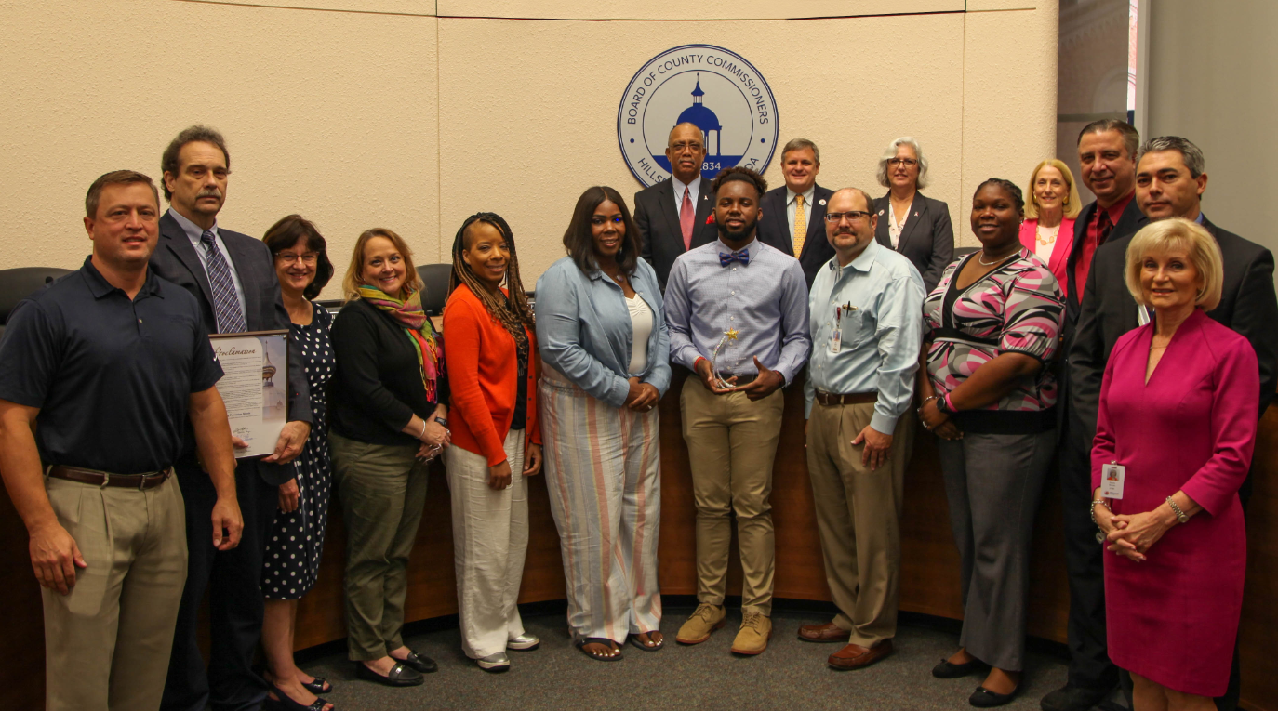

Commissioner Sandy Murman presented the Bullying Prevention Month proclamation and the 2nd Annual Anti-Bullying Recognition Award. The award was received by N’Jhari Jackson. N’Jhari was nominated and received the award for his countless hours of volunteer work and his deep desire to stand up for others who feel bullied. “Today we recognize an exception young man for his accomplishments and his positive example of what one youth can do in our community. He epitomizes the reason we are here to recognize youth leadership”, stated Commissioner Murman


Tampa among best cities for foodies
Foodies looking for their next food stop may want to consider Tampa.
A recent report by personal finance website WalletHub ranked Tampa as the 13th best foodie city in America. The report ranked the cities based on a composite score of their affordability and diversity/quality and availability. The score is based on a variety of metrics including the cost of groceries, affordability of high-end restaurants and restaurants per capita, to name a few.

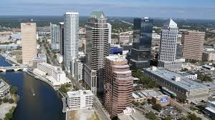
Tampa ranks among best cities to retire
Florida's reputation as a haven for retirees continues to hold up.
Nine Florida cities are among the nation's top 30 places to retire, according to U.S. News & World Report's 2020 Best Places to Retire List. The No. 1 city on the list, released Tuesday, is located in the Sunshine State. Overall, the state had nine cities in the top 30.

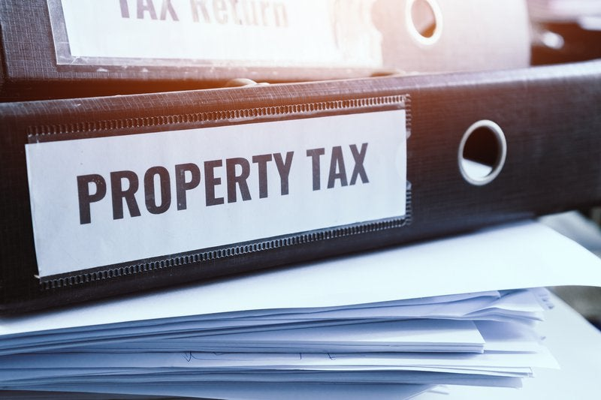
Tampa ranks among U.S. cities for lowest property tax rates
Tampa ranks among the cities with the lowest taxes on businesses in the U.S., according to a recent report. When it comes specifically to commercial property tax rates, the Big Guava also performed well compared to other cities in the nation. That's according to an Arizona State University "Doing Business in North America" report, which examined around dozens of large U.S. cities.

How Can I Lower My Water Bill?
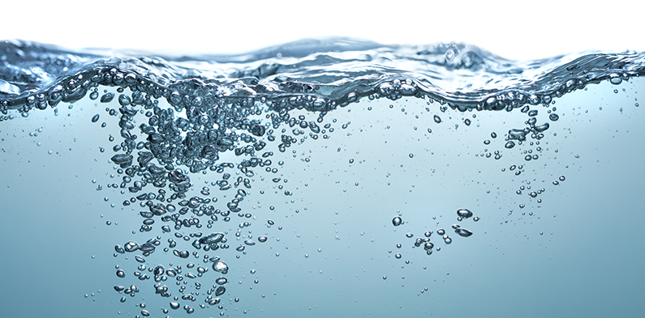

Practicing water conservation keeps the environment healthy, and can also help you save money on your water bill. Water is used all around the house, see below for some of the best ways to use your water effectively and keep your water usage down.

In the bathroom
- Check for a faulty toilet flapper/stop valve by adding a few drops of food dye into the tank and waiting about 15 minutes
- Get an ultra-low-flow toilet, which uses only 1.6 gallons per flush
- Save about 20 gallons of water by only filling the bathtub halfway
- Save between 15 to 30 gallons by reducing shower time by 5 minutes
- Install a low-flow showerhead
- Turn off the sink while brushing your teeth or shaving

In the kitchen
- Hand-washing typically uses 16 gallons of water, compared to only 9.2 to 12.4 gallons for the dishwasher
- Avoid pre-rinsing dishes
- Only turn on the dishwasher when it is full
- Put a jug of water in the fridge instead of letting the water run until cold

In the yard and garden
- Adjust sprinkler heads so they are not watering sidewalks, driveways and roads.
- Replace broken sprinkler heads
- Only water when lawn or plants shows signs of needing it
- Set you mower blade higher during growing season since tall grass retains moisture better than short grass
- Install low-volume irrigation systems for plants where possible
- Plant native and drought-tolerant plants, bushes and flowers
- Install paths, decks/patios and other Florida-friendly landscaping to reduce the amount of lawn area that needs watering

UPCOMING EVENTS IN THE COUNTY

Wednesday, October 16th 9:00 AM – Regular Board of County Commissioners Meeting, County Center

Thursday, October 17th 9:00 AM – Environmental Protection Commission Meeting, County Center

Friday, October 18th 8:30 AM to Noon - County Job Fair, HCC Dale Mabry Campus, Student Service Building
Click on this to see a list of BOCC Agendas
WHAT’S ON THE BOCC AGENDA?
STAY CONNECTED

Call my Office: 813-272-5470 | www.sandymurman.com

