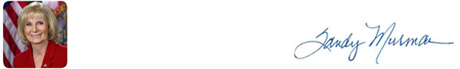
HEADLINES FROM HILLSBOROUGH COUNTY

November 8, 2019


On Veterans Day we must reflect on what it truly means to live in freedom. We owe all of our veterans, men and women, past and present, a debt of gratitude for their sacrifices in defense of liberty. We owe it to the heroes that died and the loved ones who remain to make sure that these sacrifices are remembered and their service to this great nation will always be honored. May God bless our veterans.

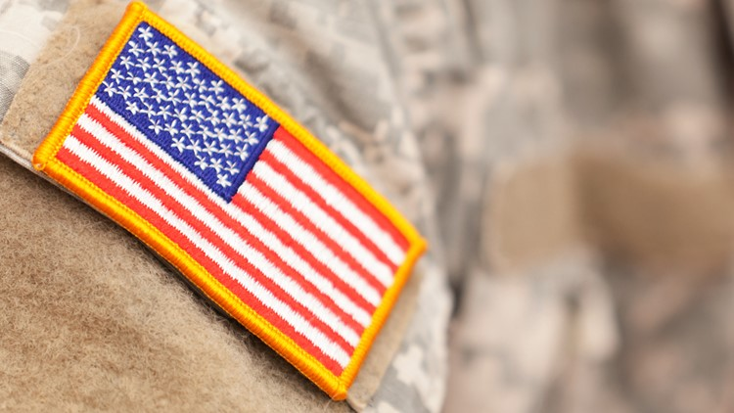
Tampa tops the list as best city in the U.S. for veterans to live
According to a new study by WalletHub, Tampa is the best city for veterans to live in the U.S. With more than 19.2 million veterans living in the U.S. and around 37,800 of them experiencing homelessness, according to the U.S. Department of Veteran Affairs, it is important for veterans to find the best place to settle. Tampa topped the list at 72.44 points, with their highest ranking falling under veteran quality of life, scoring big with veteran job fairs, veteran income growth, and retiree-friendliness. Though, when it comes to veteran housing affordability Tampa has some work to do.


USF among top Best for Vets: Colleges 2019
At the University of South Florida, military-connected students are retained, complete courses and graduate at higher rates, on average, than their peers at other schools that provided this information on the survey. They also have a slightly higher GPA than non-military students at the school – 3.21, compared to 3.17.
“The university has made it a point, no matter the issue, to work with veterans from the moment they show interest in the school, through their matriculation and even beyond graduation into their future career,” said Air Force veteran and University of South Florida graduate Aimee Carpenter, now an admission and benefits coordinator at the school. “At any point throughout their journey, the Office of Veteran Success is there to help our student veterans in any way they can.”


10 Facts for Unfurling Your Flag on Veteran's Day
Since its adoption by the Second Continental Congress on June 14, 1777, the United States flag is more than just a symbol. It is a living testament to the courageous Americans who fought and sacrificed for the nation and the freedoms it upholds. With regard to the display, etiquette, and disposal of the American flag during this holiday, here are some helpful tips from the Florida Department of State website. CLICK HERE for list

Hillsborough County Commissioners Raise Vaping to 21

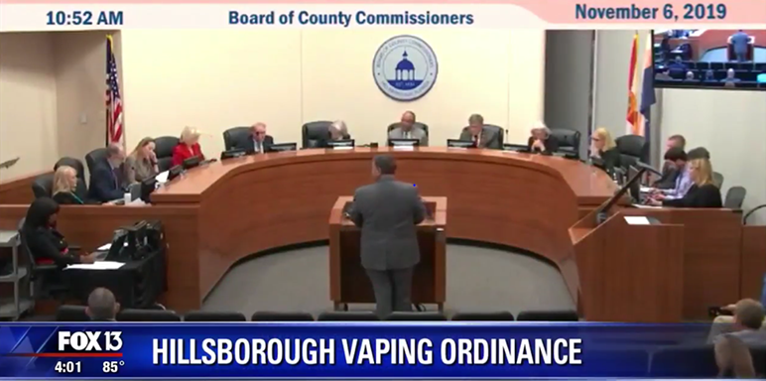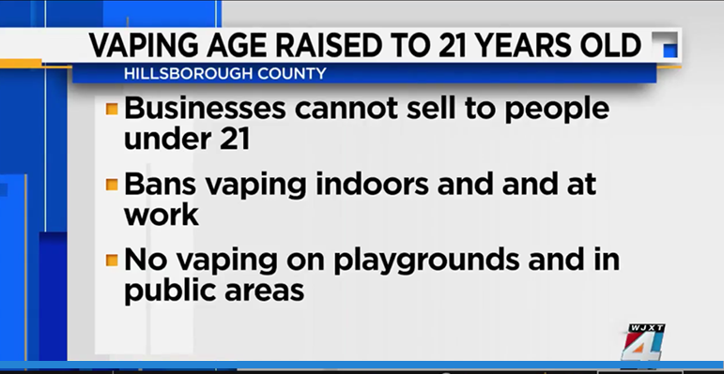
Hillsborough Vaping Ordinance Vaping Raised to 21
WTVT (Fox) – Tampa WJXT – Jacksonville

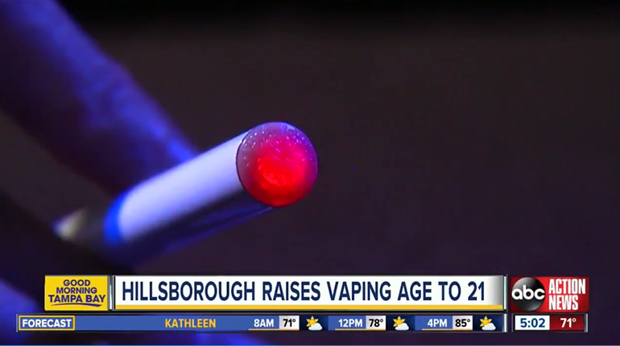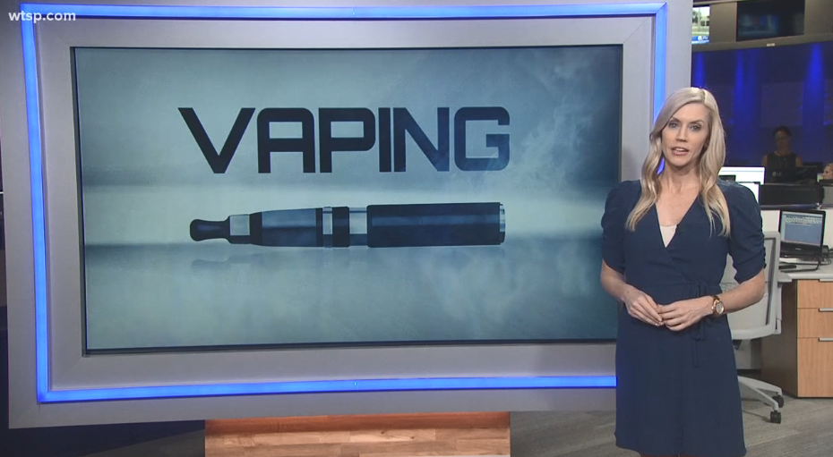
Hillsborough Raises Vaping Age to 21 County Votes to Raise Vaping Age to 21
WFTS (ABC) – Tampa WTSP.com – Tampa
Hillsborough commissioners raise vaping age to 21
County commissioners unanimously approved a sweeping new ordinance Wednesday that raises the legal vaping age from 18 to 21 years old. The change makes it illegal for stores to sell products to under-age customers and prohibits anyone under the age of 21 from even possessing a vaping device or other paraphernalia. The change comes at a time when the rising number of lung illnesses and deaths linked to vaping has sparked similar discussions across the country.

Hillsborough County votes to raise legal vaping age to 21
Several counties have considered similar ordinances but have decided to hold-off until the legislature takes up the vaping issue in January. Florida lawmakers are expected to raise the vaping age to 21 statewide, but Hillsborough commissioners said they did not want to wait that long or risk the possibility that the proposal would get derailed at the state level. So, commissioners decided to move forward, voting unanimously to raise the vaping age to 21 while leaving the door open to more.

Hillsborough County passes ordinance raising vaping age, restricting smoking areas
Lawmakers in Hillsborough County voted today to crack down on the teen vaping epidemic. On Wednesday, commissioners voted 7-0 on a measure to ban Hillsborough County businesses from selling vape devices or products to anyone younger than 21. The measure also bans anyone under 21 from using or possessing vape devices or products. Lastly, the ordinance also restricts people from vaping indoors at work, anywhere else where smoking is not allowed, as well as playgrounds, and any public places where there are children, even if it’s outdoors. Penalties range from $25 to $100 depending on the violation. The penalties double for the fourth offense.

UPCOMING EVENTS IN THE COUNTY

Monday, November 11th County offices will be closed in observance of Veterans Day

Tuesday, November 12th BOCC Land Use Meeting, County Center

Click on this to see a list of BOCC Agendas
WHAT’S ON THE BOCC AGENDA?
STAY CONNECTED

Call my Office: 813-272-5470 | www.sandymurman.com

